Login to Jenkins with provided account

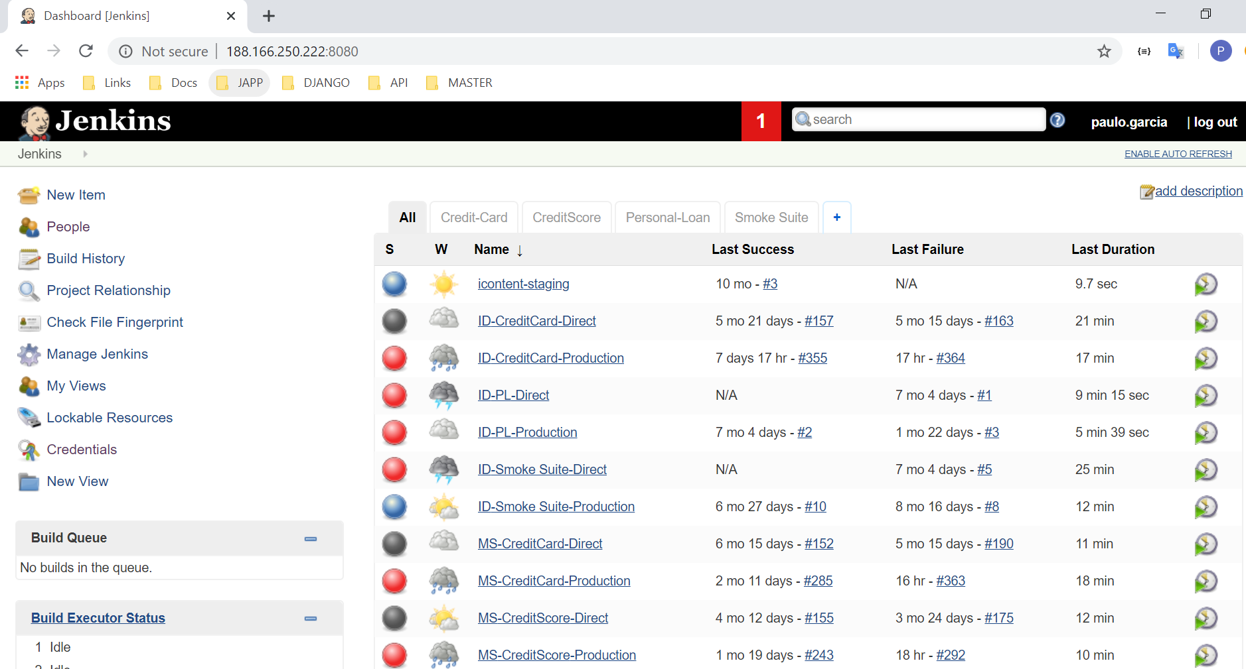

Click New Item to add

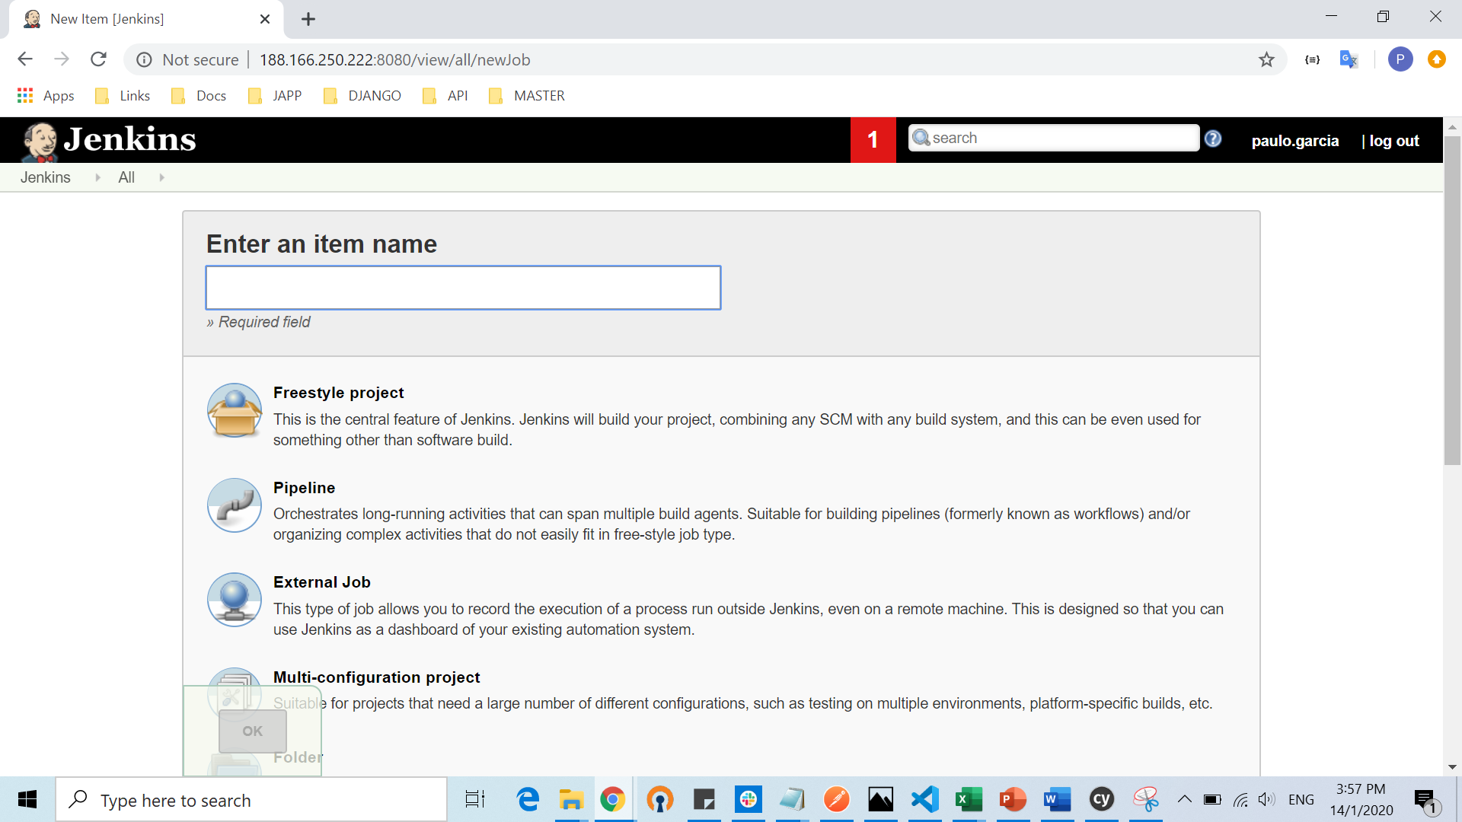

Specify name of project then select Freestyle project and click OK

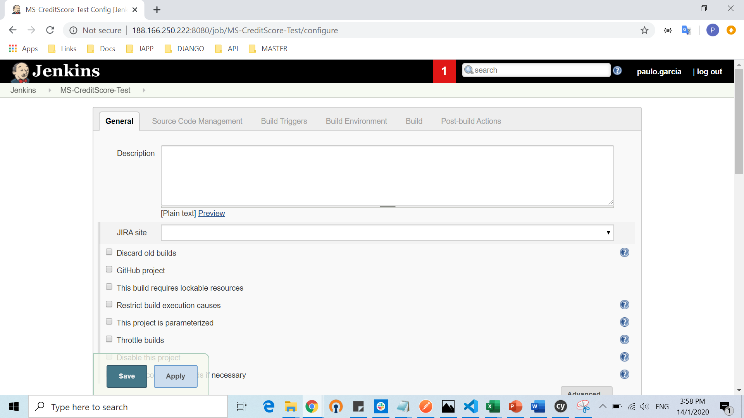

Then start to configure

-Set GitHub project (Either Master/Staging/Local branch)

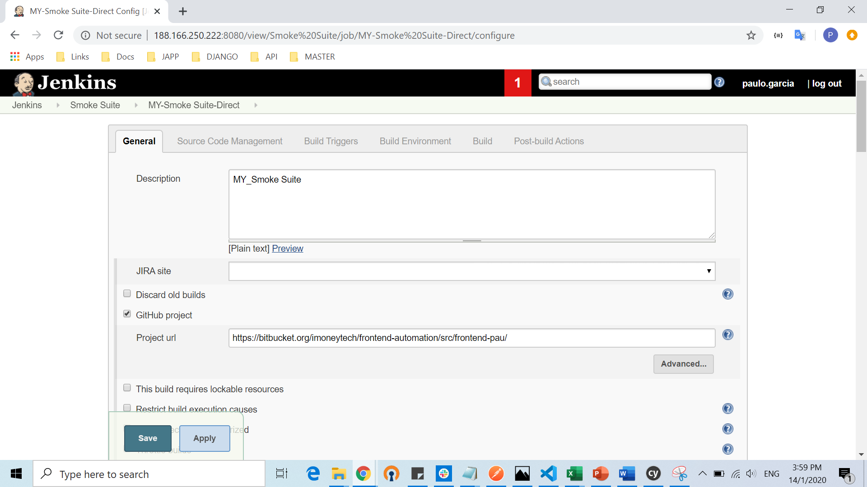

Source Code Management

-Set Repository URL (Clone (copy)from Master branch)

-Set Credentials of Bitbucket access

-Set branch (Either Master/Staging/Local (for faster update)

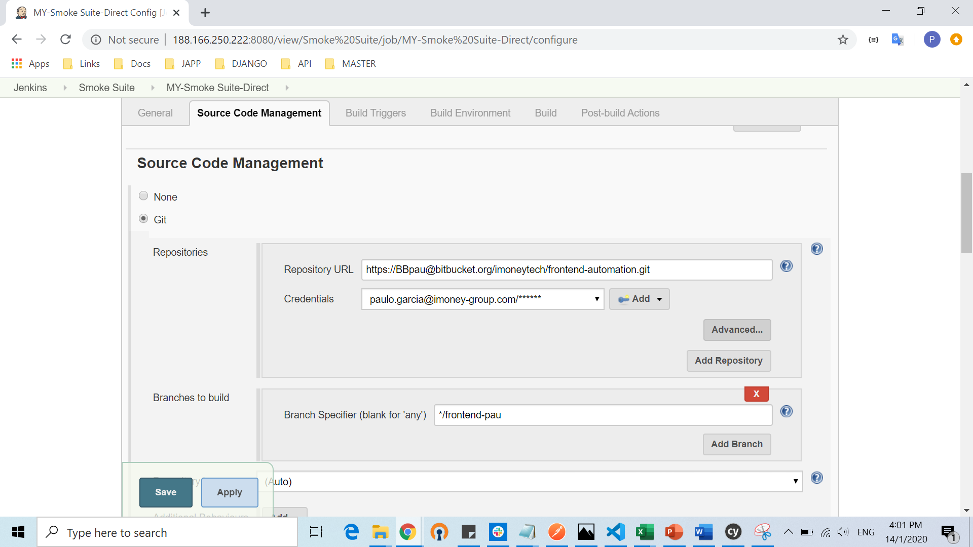

Build Triggers

-Build Periodically (Set time (schedule) of run of scripts)

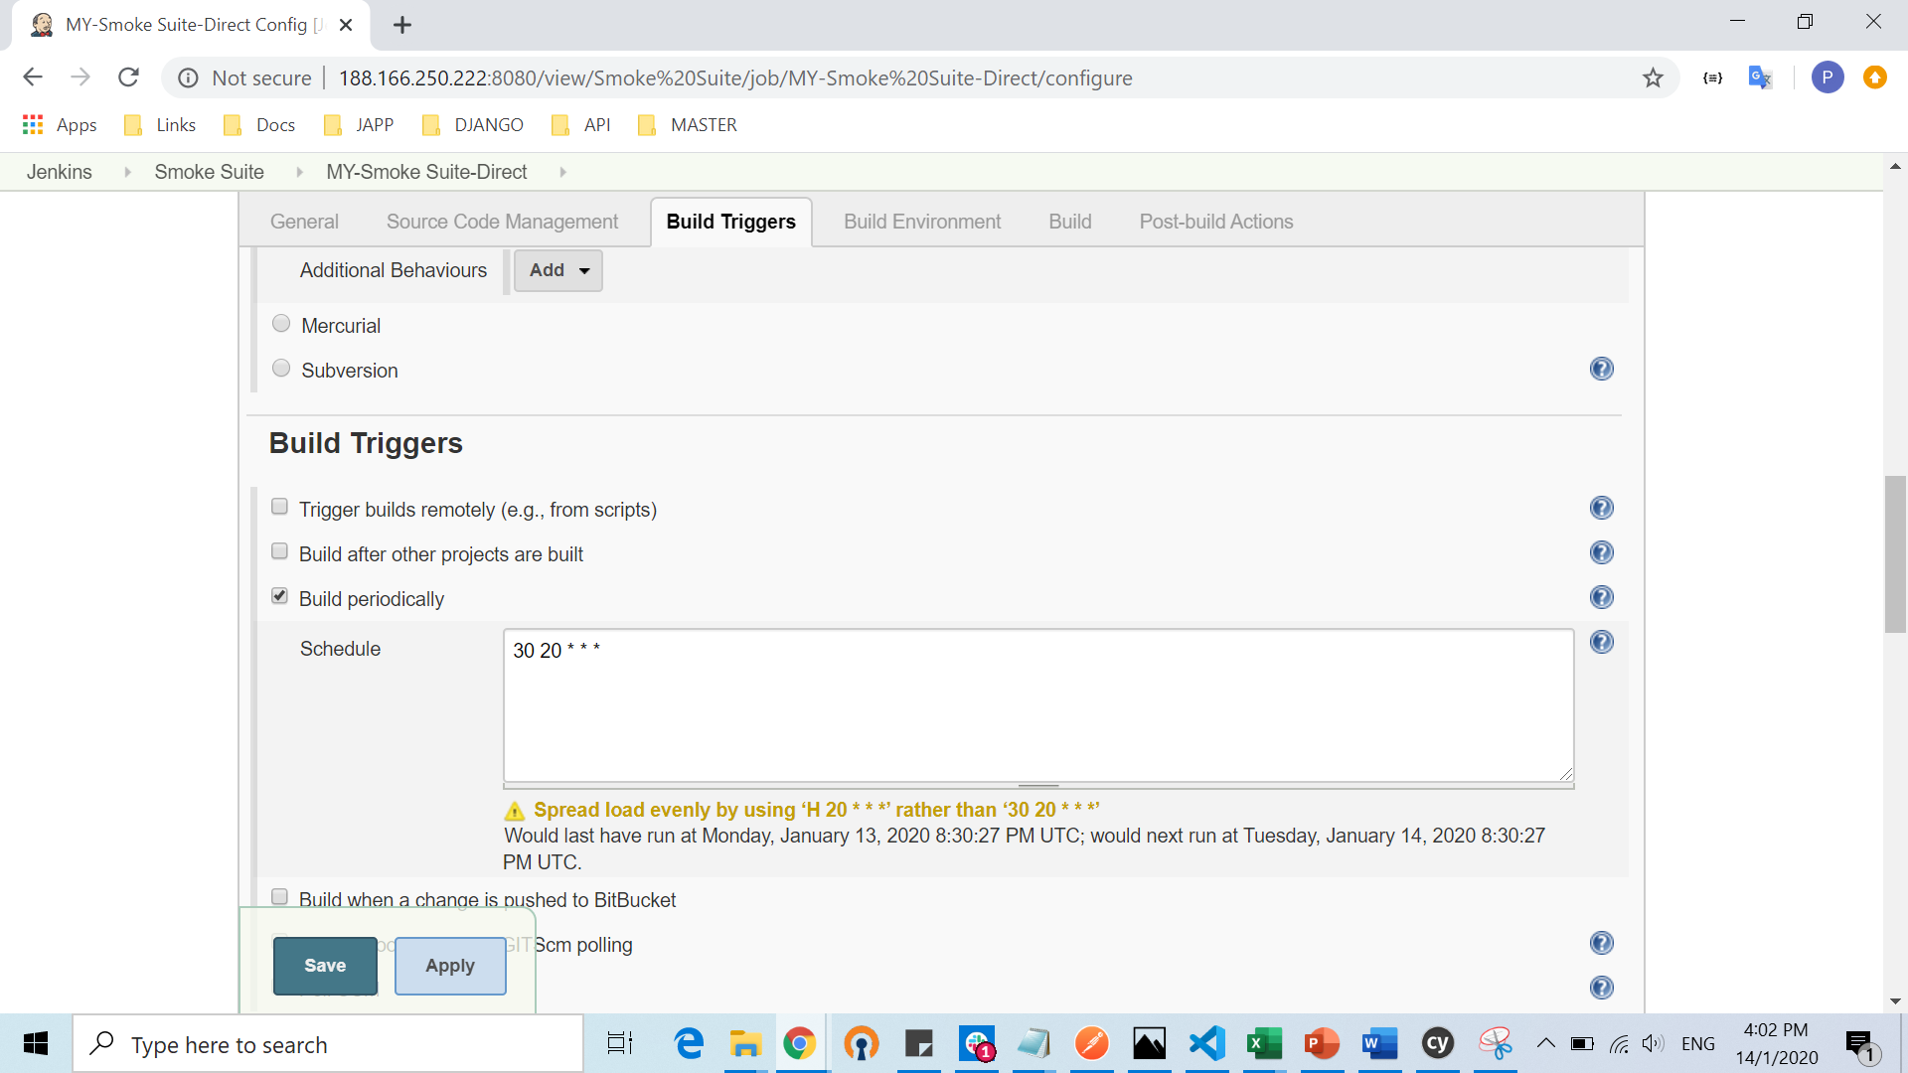

Build

-Set command execution

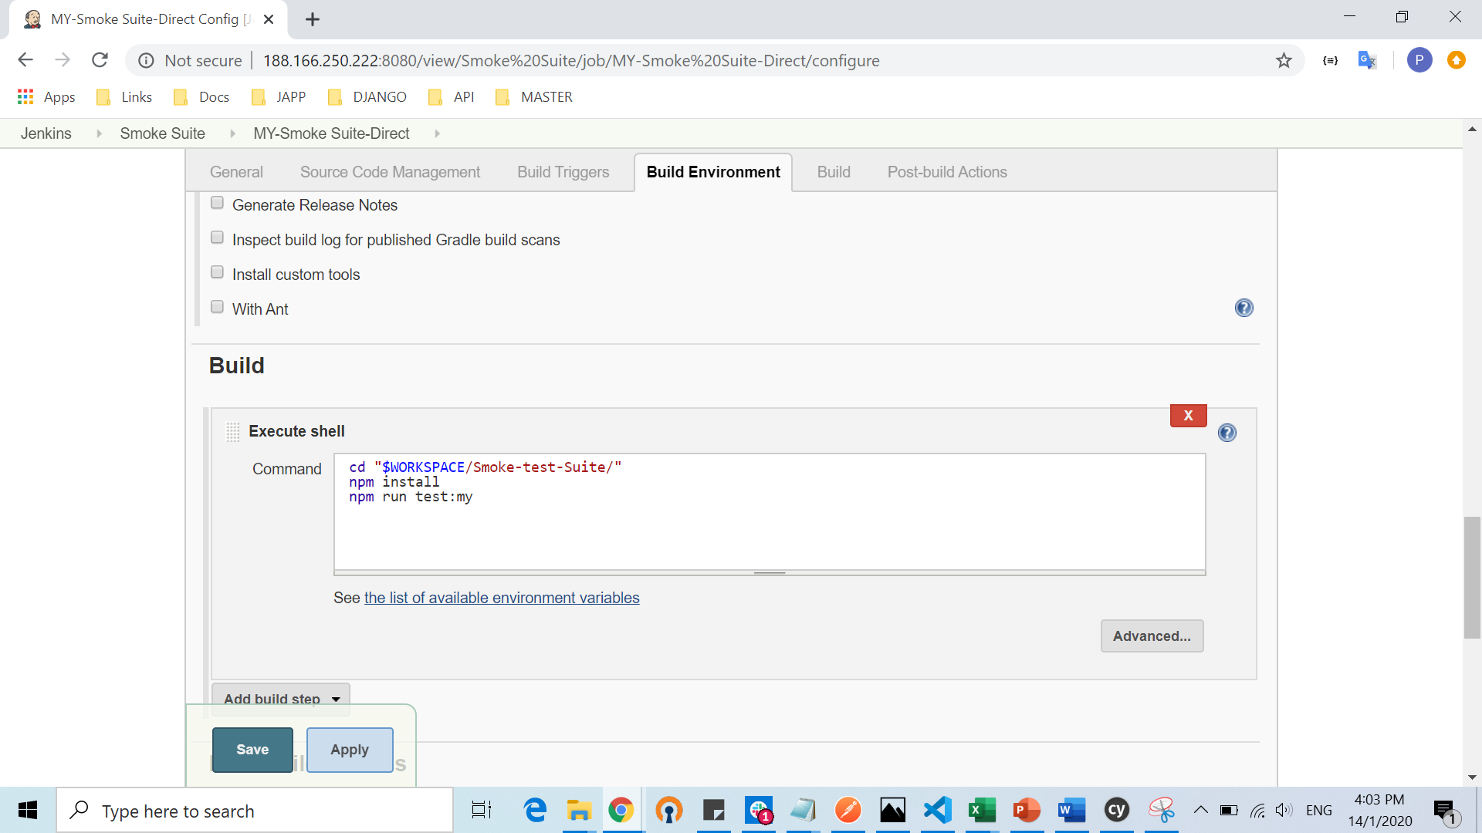

Apply and Save